Please make the following updates to the customization:

1. The format of the Inbound Shipment field needs to be fixed so that it does not show a comma. Example: Screenshot below should just be 1272 not 1,272.

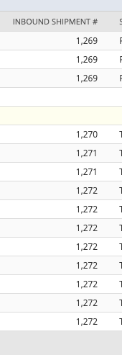

1. When the status is updated on the Inbound Shipment, this needs to update the custom record. If you look at inbound shipment 1272 it was loaded into the custom record with a status of ‘To Be Shipped’, but after I marked it in transit to have the status be In Transit, I re-ran the script, but it did not update the table. The update can be managed via the scheduled script. It does not have to be a user event.

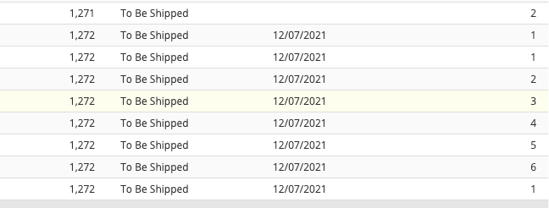

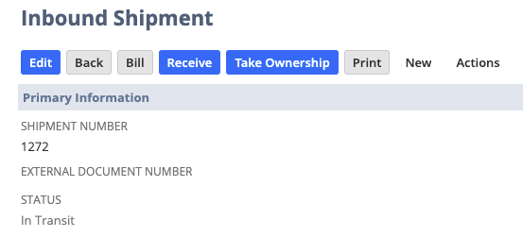

1. Expected Receipt Date: There are a couple of updates I would like to do for this one.
   * Expected Receipt Date should be populated from the purchase order when the purchase order is originally created and then any time that expected receipt date is updated for that purchase order line, it should update the expected receipt date in the custom record.
   * Once an Inbound Shipment is created, the Expected Receipt Date should populate from the Inbound Shipment (like it is now) and replace the Expected Receipt Date that was in the field from the purchase order and any time the Expected Receipt Date is updated on the Inbound Shipment, it should update the custom record (this can be handled via the scheduled script. It does not have to be a user event). Once an Inbound Shipment is created the logic should NOT pull expected receipt date updates from that purchase order line any anymore.

Example: If Inbound Shipment Number = FALSE then update Expected Receipt Date from Purchase Order Line, else update Expected Receipt Date from Inbound Shipment.

When pulling/updating the Expected Receipt Date from the purchase order it should be from the line level field for the related line that is in the custom table.

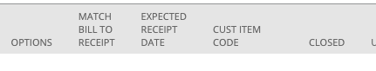

When pulling/updating the Expected Receipt Date from the Inbound Shipment, that is coming from the header level field Expected Delivery Date of the Inbound Shipment (I think you already have this set, we just need it to update as well).

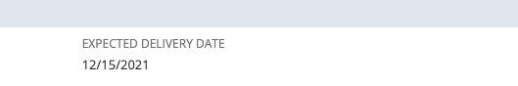

1. When the Inbound Shipment detail is being loaded into the custom record, the script is populating each line of the purchase order with the inbound shipment detail, even if only some of the purchase order lines are on the inbound shipment.

Example: If you look at purchase order 36132 there are 6 lines on the purchase order, but only three of them were added to inbound shipment 1272. If I look in the custom record, all 6 lines are referencing the inbound shipment. We should only update the lines associated with the inbound shipment. You will probably have to match by purchase order number and po line ID.

Purchase Order 36132: has 6 total lines

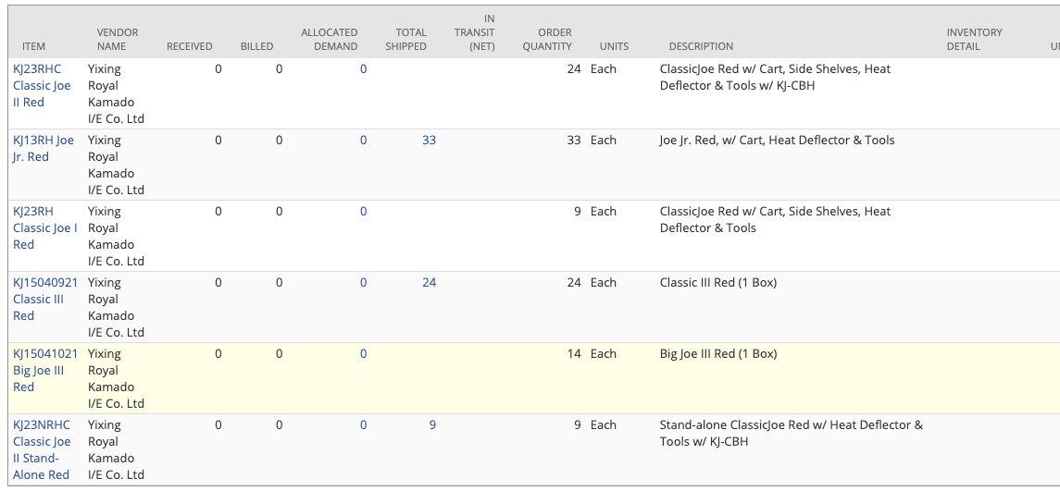

Inbound Shipment: only 3 lines from PO36132

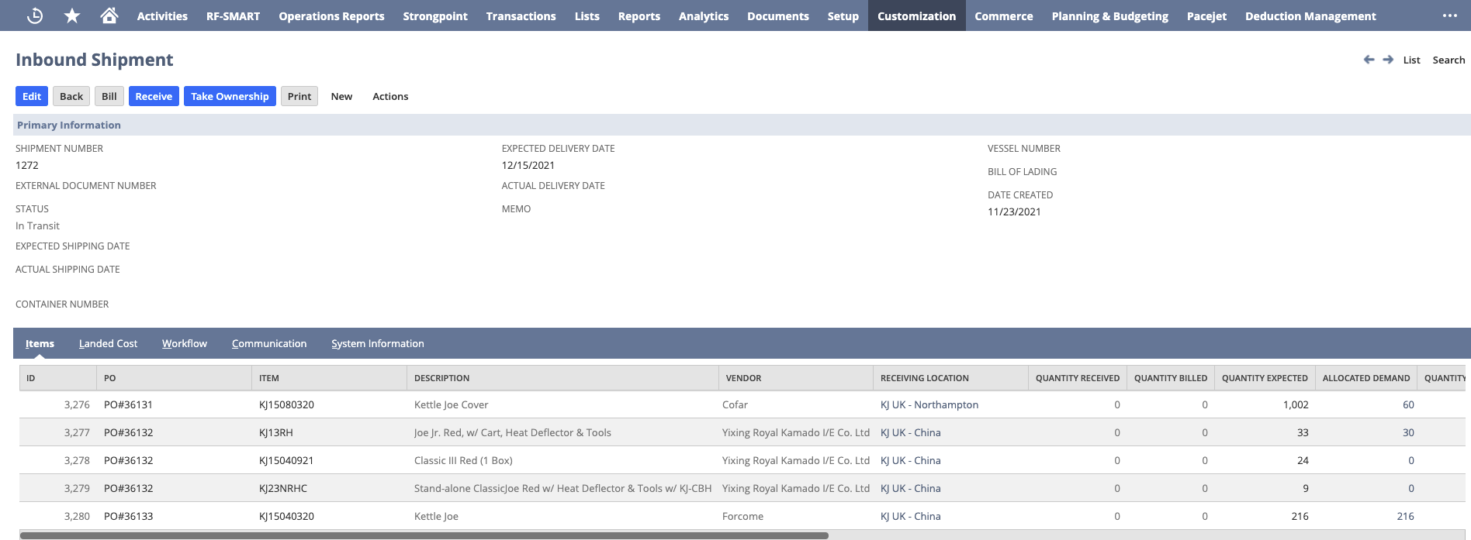

Custom Record: Shows all 6 lines referencing the inbound shipment, but on three of them should.



1. Can you add the following fields from the purchase order line.
   * Order Quantity
   * Total Shipped
   * Received

